**Practical: 4**

**Que:1 Read two values from a file and make addition, subtraction, division and multiplication.**

var fs = require('fs');

fs.readFile("p4_01.txt",function(err,data){

    if(err)

    {

        console.log(err);

    }

    else

    {

        var str = data.toString().split(' ');

        var num1 = parseInt(str[0]);

        var num2 = parseInt(str[1]);

        console.log("Addition is: "+(num1+num2))

        console.log("Subtraction is: "+(num1-num2))

        console.log("Multiplication is: "+(num1*num2))

        console.log("Division is: "+(num1/num2))

    }

});

**Output:**

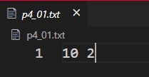 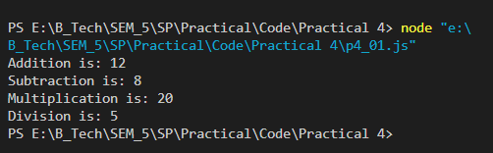

**Que:2 Differentiate between synchronous and asynchronous file reading by example.**

var fs = require('fs');

//Sync Read

console.log("*****Sync File Read*****");

console.log(fs.readFileSync('p4_01.txt').toString());

console.log("Read Complete\n");

//Async Read

console.log("*****Async File Read*****");

fs.readFile('p4_01.txt',function(err,data){

    if(err)

    {

        console.log(err);

    }

    else{

        console.log(data.toString());

    }

});

console.log("Read Complete");

**Output:**

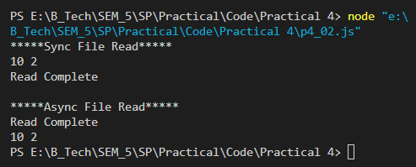

**Que:3 For the given string in the text file,split it into substrings which is separated by ‘|’ (pipe) and display the result.**

String: This|is|UVPCE|of|Ganpat|university

var fs = require('fs');

fs.readFile('p4_03.txt',function(err,data){

    if(err)

    {

        console.log(err);

    }

    else{

        var str = data.toString().split('|');

        str.forEach(str_val=>{

            console.log(str_val);

        });

    }

});

**Output:**

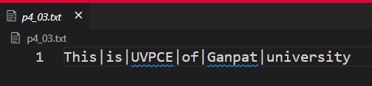

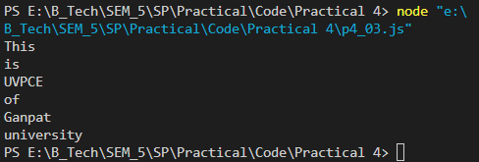

**Que:4 Write the following content in the html file using writeFile().**

**Content:**

<html>

<head>

<title>

A Simple HTML Document

</title>

</head>

<body>

<p>This is a very simple HTML document</p>

<p>It only has two paragraphs</p>

</body>

</html>

var fs = require('fs');

var str="<html>"+

"<head>"+

"<title>"+

"A Simple HTML Document"+

"</title>"+

"</head>"+

"<body>"+

"<p>This is a very simple HTML document</p>"+

"<p>It only has two paragraphs</p>"+

"</body>"+

"</html>";

fs.writeFile('p4_04.html',str,function(err){

    if(err)

    {

        console.log(err)

    }

    else{

        console.log("File Write Sucessful");

        console.log(fs.readFileSync('p4_04.html').toString());

    }

});

**Output:**

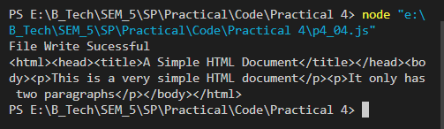

**Que:5 Create an empty text file (file without content).**

var fs = require('fs');

fs.writeFile('empty.txt','',function(err){

    if(err){

        console.log(err);

    }

    else{

        console.log("File Created");

    }

});

**Output:**

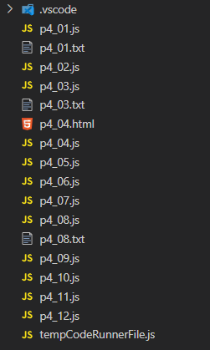 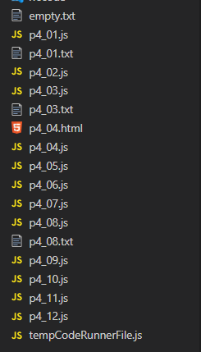

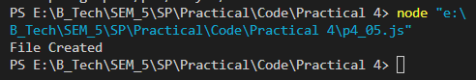**.**

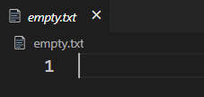

**Que:6 Rename the existing file with the new name and display system’s error’s message if it doesn’t exist.**

var fs = require('fs');

fs.writeFile('p4_06.txt','Hi',function(err)

{

    if(err)

    {

        console.log(err)

    }

    else{

        console.log('File Created');

        fs.rename('p4_06.txt','p4_06_edited.txt',function(err)

        {

            if(err)

            {

                console.log(err);

            }

            else{

                console.log('File Renamed');

                console.log("Old Filename: p4_06.txt");

                console.log("Old Filename: p4_06_edited.txt");

            }

        });

    }

});

**Output:**

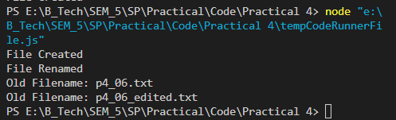



**Que:7 Delete the existing file and display system’s error’s message if it doesn’t exist.**

var fs = require('fs');

fs.writeFile('p4_07.txt',"Hello",function(err){

    if(err){

        console.log(err);

    }

    else{

        console.log('File created');

        fs.unlink('p4_07.txt',function(err){

            if(err)

            {

                console.log(err);

            }

            else{

                console.log('File Deleted')

            }

        });

    }

});

**Output:**

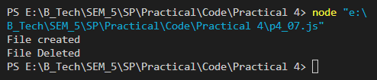

**Que:8 Take the existing file and add new 3 lines in it.**

var fs = require('fs');

fs.writeFile('p4_08.txt','Hello',function(err){

    if(err)

    {

        console.log(err)

    }

    else{

        console.log('*****File created*****');

        console.log(fs.readFileSync('p4_08.txt').toString()+"\n");

        fs.appendFile('p4_08.txt',"\r\nHi\r\nHow Are You\r\nKem

Chho\r\n",function(err){

            if(err)

            {

                console.log(err)

            }

            else

            {

                console.log("*****File Appended*****");

                console.log(fs.readFileSync('p4_08.txt').toString());

            }

        });

    }

});

**Output:**

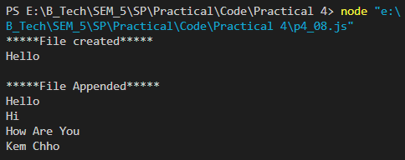



**Que:9 Print your bio-data using util.format in the console.**

**(your bio data should contain Name, age, mobile no, email_id, resident address, education qualification, occupation and current timestamp.)**

const util = require('util');

var name ="Dhavanik";

var age=21;

var mobile_no=7621976813;

var email_id="dhavanik@gmail.com";

var resident_address="Mehsana";

var edu_qualification="B.Tech IT Running 3 Year 5th SEM";

var occupation="Study"

util.log(util.format("Name is: %s",name))

util.log(util.format("Age is: %d",age))

util.log(util.format("Mobile Number is: %d",mobile_no))

util.log(util.format("Email is: %s",email_id))

util.log(util.format("Resident Address is: %s",resident_address))

util.log(util.format("Education Qualification is: %s",edu_qualification))

util.log(util.format("Occupation is: %s",occupation))

**Output:**

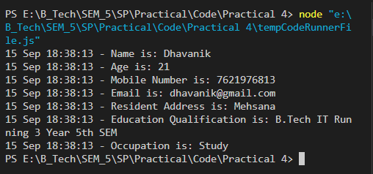

**Que:10 Print the host and hostname from the given URL.**

**URL:** [**https://www.uvpce.ac.in:11/content/syllabus-it**](https://www.uvpce.ac.in:11/content/syllabus-it)

const value_url=new URL('https://www.uvpce.ac.in:11/content/syllabus-it');

console.log("Host : "+value_url.host);

console.log('Hostname : '+value_url.hostname);

**Output:**

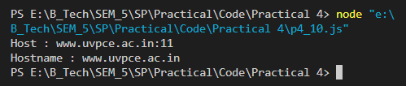

**Que:11 Using the search property of URL, print search parameters (after the '?') for the following url.**

[**https://www.google.com/search?sxsrf=ALeKk00zkMmOlhl2IKbhPhHy_gY57KJN_g%3A1598340885542&source=hp**](https://www.google.com/search?sxsrf=ALeKk00zkMmOlhl2IKbhPhHy_gY57KJN_g%3A1598340885542&source=hp)

const url_value=new URL("https://www.google.com/search?

sxsrf=ALeKk00zkMmOlhl2IKbhPhHy_gY57KJN_g%3A1598340885542&source=hp");

console.log(url_value.searchParams);

**Output:**

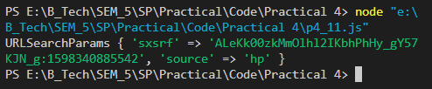

**Que:12 Parses a path to an object with the segments that compose it:**

**root: the root**

**dir: the folder path starting from the root**

**base: the file name + extension**

**name: the file name**

**ext: the file extension**

**PATH: H:\\BACKUP\\node\\myexamples\\CIRCLE.js**

const path=require('path');

var path_link="H:\\BACKUP\\node\\myexamples\\CIRCLE.js";

console.log('Root: '+path.parse(path_link).root);

console.log('Dir: '+path.parse(path_link).dir);

console.log('BaseName: '+path.parse(path_link).base);

console.log('FileName: '+path.parse(path_link).name);

console.log('File Extension: '+path.parse(path_link).ext);

**Output:**

